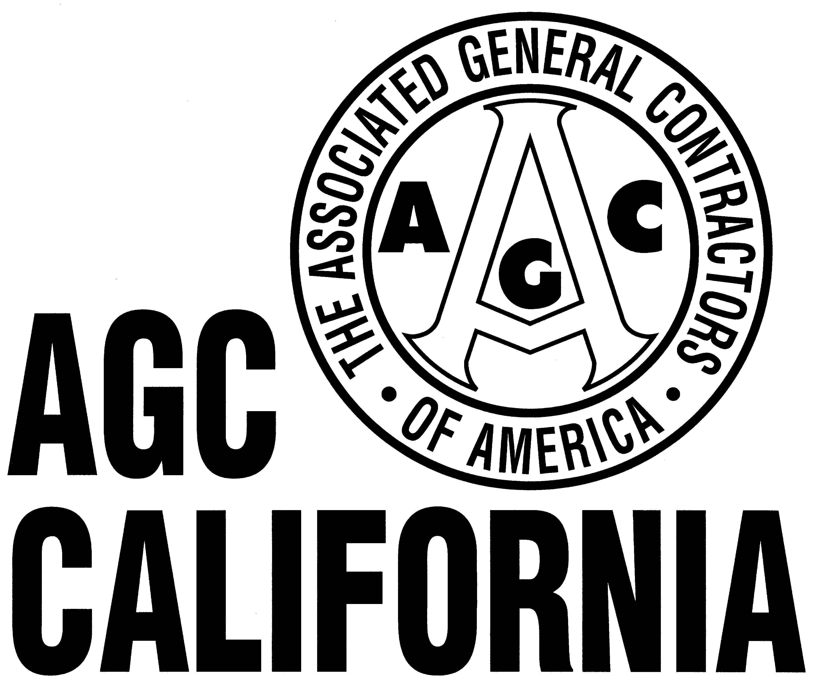

3095 BEACON BOULEVARD / WEST SACRAMENTO, CA 95691 / 916.371.2422 | FAX 916.371.2352 | E-mail: agcsac@agc-ca.org

July 27, 2006 Contact: Pam Gray (916) 371-2422

FOR IMMEDIATE RELEASE

AGC kicks off ‘Emerging Contractor Forums’ to mentor small, minority-owned and women-owned businesses

In partnership with Caltrans and other public agencies, AGC of California today announced the first of a series of “Emerging Contractor Forums” to be held at different locations statewide with the goal of providing mentoring and business-development opportunities for small, minority-owned and women-owned construction companies.

The announcement comes on the heels of a partnership agreement signed July 21 between five AGC members and Caltrans, members of the state Small Business Council, and representatives from the Consulting Engineers and Land Surveyors of California. The agreement, presented to Gov. Arnold Schwarzenegger at a Capitol ceremony, was followed with the signing of Executive Order S-11-06, which creates a Caltrans Small Enterprise officer position at the Business, Transportation and Housing Agency to assist small businesses including Disadvantaged Business Enterprises (DBEs) to grow their businesses within the state.

The Emerging Contractor Forums will build on this partnership by leveraging the knowledge and experience of established AGC contractors to mentor up-and-coming firms.

Tom Holsman, AGC Chief Executive Officer said, “Our aim with these forums is to provide an easily accessible opportunity for the emerging contractor and related business to make those vital business relationships and to acquire timely and valuable knowledge to help them be successful in our industry.

“With many billions of dollars of public works projects in the pipeline,” Holsman noted, “there will be many opportunities for emerging businesses to assist our industry in delivering the schools, roads, levees and other improvement projects the public demands.”

Several public agencies, including the California Department of Transportation (Caltrans), the San Francisco Public Utilities Commission, BART and the Valley Transportation Authority (Santa Clara County) have agreed to support the inaugural forum, which will be held October 5 at the Holiday Inn in Emeryville. A panel discussion at the forum will focus on cost and difficulty of obtaining insurance, including a new proposal by Caltrans to raise the limits on insurance contractors must carry and how that might impact industry. For more information on the Emerging Contractor Forums, contact Russell Snyder at (925) 827-2422.

The Associated General Contractors of California, “the voice of the construction industry,” is the largest statewide construction trade association in California. Founded in 1920, AGC represents more than 1,100 firms of leading general contractors specialty-contracting and service providers and suppliers. Visit the AGC of California web site at www.agc-ca.org.

.
###

